## Palestinian or Land Covenant

The Palestinian Covenant is God’s promise to Abraham as the first Jew and to his descendants of actual land in the Middle East for the nation of Israel. This covenant is an eternal covenant. The land appears as the first part of the Abrahamic Covenant given by God to Abraham and his descendants – the Jews. It is theirs unconditionally, literally and eternally.

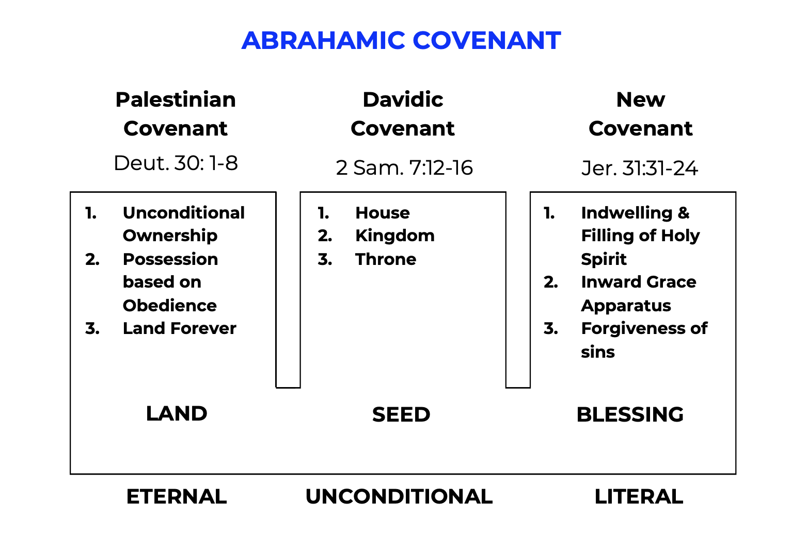

Boundaries of the Land

This land covenant includes all of the Middle East from the Mediterranean Sea to the Euphrates River, all of Turkey, and half of Egypt and Ethiopia. The racial Jew must become a believer in Jesus Christ to inherit this promise. Gen. 13:14-15; Gen. 15:18.

"The LORD said to Abram, after Lot had separated from him, "Now lift up your eyes and look from the place where you are, northward and southward and eastward and westward; for all the land which you see, I will give it to you and to your descendants forever." (Genesis 13:14-15, NASB)

"On that day the LORD made a covenant with Abram, saying, "To your descendants I have given this land, From the river of Egypt as far as the great river, the river Euphrates:" (Genesis 15:18, NASB)

Genesis 15:18 stresses the large amount of land promised to Abraham and his descendants. The dimensions are much greater than the 183 mile by 25-52 mile section from Dan to Beersheba and the Mediterranean to Jordan River area. Has Israel ever dominated the larger area completely in past history? No. Not even in Solomon’s time.

Israel possessed the land under Joshua. Israel was taken from land. The Northern Kingdom to Assyria and the Southern Kingdom to Babylon. Israel was later completely scattered in 70 AD when Titus the Roman general and his armies completely destroyed Jerusalem. James 1:1.

"James, a bond-servant of God and of the Lord Jesus Christ, To the twelve tribes who are dispersed abroad: Greetings." (James 1:1, NASB)

All 12 tribes of Israel will be returned to the land to possess it. The Lord is the one who will bring them back. Israel as a nation today in Palestine is not recognized biblically as the nation of Israel to whom God's Palestinian Covenant applies. God's covenants all are with regenerate Jews – believers in the Lord Jesus Christ.

Two factors are necessary for the Jews to enjoy their land - faith for ownership and obedience for blessing. The nation of Israel began on the principle of faith. But those who made up that original beginning are long expired, so those Jews living today as the heirs of the promise of Abraham by race must also become Jews by faith. Rom. 2.

The time for the possession of the Land will come simultaneously with the principle of faith and obedience; i.e., when the Lord returns at the Second Advent.

Confirmation of the Palestinian Covenant

The Palestinian Covenant or Land Covenant was confirmed to Isaac with a more specific reference to Gerar which is today south of Gaza. Gen. 26:1-4.

"Now there was a famine in the land, besides the previous famine that had occurred in the days of Abraham. So Isaac went to Gerar, to Abimelech king of the Philistines. The LORD appeared to him and said, "Do not go down to Egypt; stay in the land of which I shall tell you. "Sojourn in this land and I will be with you and bless you, for to you and to your descendants I will give all these lands, and I will establish the oath which I swore to your father Abraham. "I will multiply your descendants as the stars of heaven, and will give your descendants all these lands; and by your descendants all the nations of the earth shall be blessed;" (Genesis 26:1-4, NASB)

The land covenant was also confirmed to Jacob and Moses. Gen. 35:12; Exod. 6:2-8.

""The land which I gave to Abraham and Isaac, I will give it to you, And I will give the land to your descendants after you."" (Genesis 35:12, NASB)

""I also established My covenant with them, to give them the land of Canaan, the land in which they sojourned." (Exodus 6:4, NASB)

Moses described the detailed land boundaries promised and prophesied that the covenant would be fulfilled by God in the Millennium. To encourage Israel to enter the land, the Palestinian Covenant was reconfirmed to Joshua to motivate him to lead Israel in conquering as much of the land that he could. Num. 34:1-12; Deut. 30:1-9; Joshua 1:2-4.

""Moses My servant is dead; now therefore arise, cross this Jordan, you and all this people, to the land which I am giving to them, to the sons of Israel. "Every place on which the sole of your foot treads, I have given it to you, just as I spoke to Moses. "From the wilderness and this Lebanon, even as far as the great river, the river Euphrates, all the land of the Hittites, and as far as the Great Sea toward the setting of the sun will be your territory." (Joshua 1:2-4, NASB)

Jeremiah and Ezekiel confirmed that the Palestinian Covenant will not be fulfilled to the nation of Israel until the Millennial reign of Christ on earth. This covenant is therefore related to the New Covenant to Israel. Jer. 31:31-34; Jer. 32:36-44; Ezek. 11:16-21; Ezek. 36:21-38.

“"Behold, days are coming," declares the LORD, "when I will make a new covenant with the house of Israel and with the house of Judah, not like the covenant which I made with their fathers in the day I took them by the hand to bring them out of the land of Egypt, My covenant which they broke, although I was a husband to them," declares the LORD. "But this is the covenant which I will make with the house of Israel after those days," declares the LORD, "I will put My law within them and on their heart I will write it; and I will be their God, and they shall be My people. "They will not teach again, each man his neighbor and each man his brother, saying, 'Know the LORD,' for they will all know Me, from the least of them to the greatest of them," declares the LORD, "for I will forgive their iniquity, and their sin I will remember no more."” (Jeremiah 31:31-34, NASB)

The eternal ownership of the land for the seed of Abraham is by faith in Jesus Christ as their Savior. This is everlasting ownership rights given to Israel. They were given the title deed absolutely by God. It is theirs lock, stock and barrel. Is it theirs now? Do they own Palestine now? No. This covenant will be fulfilled at the Millennial rule of Jesus Christ. Gen. 17:8.

""I will give to you and to your descendants after you, the land of your sojournings, all the land of Canaan, for an everlasting possession; and I will be their God."" (Genesis 17:8, NASB)

Possession is Based on Obedience

The Palestinian Covenant is actually stated in Deut. 30:1-8. But Deuteronomy 28-29 give tremendous background and build-up to this covenant. Remember that these covenants were literal, unconditional and eternal. Deut. 28:62.

""Then you shall be left few in number, whereas you were as numerous as the stars of heaven, because you did not obey the LORD your God." (Deuteronomy 28:62, NASB)

Obedience is Based on Belief

Israel’s ownership of the land is unconditional and eternal, but possession and enjoyment of that land is based on obedience to God’s grace plan. Ultimately, Israel can only be obedient through spiritual growth.

We accept the package of salvation by believing in Christ as our personal Savior. But to enjoy our salvation we must be obedient to the Word of God in our Christian walk. Rom. 11:26-27.

"and so all Israel will be saved; just as it is written, "THE DELIVERER WILL COME FROM ZION, HE WILL REMOVE UNGODLINESS FROM JACOB." "THIS IS MY COVENANT WITH THEM, WHEN I TAKE AWAY THEIR SINS."" (Romans 11:26-27, NASB)

If the Jews in Israel were disobedient, they were disbursed (scattered). Are the Jews scattered today? Yes. Deut. 28:63-64.

""It shall come about that as the LORD delighted over you to prosper you, and multiply you, so the LORD will delight over you to make you perish and destroy you; and you will be torn from the land where you are entering to possess it. "Moreover, the LORD will scatter you among all peoples, from one end of the earth to the other end of the earth; and there you shall serve other gods, wood and stone, which you or your fathers have not known." (Deuteronomy 28:63-64, NASB)

How do the Jews feel about the Gentile nations? Secure? Remember this was written thousands of years ago. Deut. 28:65-66.

""Among those nations you shall find no rest, and there will be no resting place for the sole of your foot; but there the LORD will give you a trembling heart, failing of eyes, and despair of soul. "So your life shall hang in doubt before you; and you will be in dread night and day, and shall have no assurance of your life." (Deuteronomy 28:65-66, NASB)

The Palestinian Covenant is tied into the Abrahamic Covenant. Deut. 29:12-13.

"that you may enter into the covenant with the LORD your God, and into His oath which the LORD your God is making with you today, in order that He may establish you today as His people and that He may be your God, just as He spoke to you and as He swore to your fathers, to Abraham, Isaac, and Jacob." (Deuteronomy 29:12-13, NASB)

Ezekiel 37 presents a vision where the dry bones represent the ruined and desperate state of both Israel and Judah. These bones are revived and signifies their restoration to their own land after their captivity and also their recovery as a nation from their long dispersion since 70 AD. This chapter also indicates that the regathering begins in unbelief, but actually is not fulfilled until the Second Advent of Jesus Christ. Ezek. 37:1-10.

“The hand of the LORD was upon me, and He brought me out by the Spirit of the LORD and set me down in the middle of the valley; and it was full of bones.” (Ezekiel 37:1, NASB)

“"Thus says the Lord GOD to these bones, 'Behold, I will cause breath to enter you that you may come to life. 'I will put sinews on you, make flesh grow back on you, cover you with skin and put breath in you that you may come alive; and you will know that I am the LORD.'"” (Ezekiel 37:5-6, NASB)

Israel owns the land but cannot possess it without being obedient. They cannot be obedient without God’s indwelling Holy Spirit. They must believe in the Lord Jesus Christ for salvation. Ezek. 37:11-14.

"Then He said to me, "Son of man, these bones are the whole house of Israel; behold, they say, 'Our bones are dried up and our hope has perished. We are completely cut off.' "Therefore prophesy and say to them, 'Thus says the Lord GOD, "Behold, I will open your graves and cause you to come up out of your graves, My people; and I will bring you into the land of Israel. "Then you will know that I am the LORD, when I have opened your graves and caused you to come up out of your graves, My people. "I will put My Spirit within you and you will come to life, and I will place you on your own land. Then you will know that I, the LORD, have spoken and done it," declares the LORD.'"" (Ezekiel 37:11-14, NASB)

What covenant provides this? The New Covenant. Why can the New Covenant provide salvation through belief in Jesus Christ? Because the Davidic Covenant amplifies and explains the qualified seed, Jesus Christ. The details of the biblical jig-saw puzzle begin to fit together.

The regathering of Israel will be complete at the Second Advent of Jesus Christ. Israel will see Him whose hands they have pierced and believe (indwelt and filled by the Holy Spirit) as a nation in a day. Isaiah 11; Ezekiel 11:16-21.

""Therefore say, 'Thus says the Lord GOD, "I will gather you from the peoples and assemble you out of the countries among which you have been scattered, and I will give you the land of Israel."' "When they come there, they will remove all its detestable things and all its abominations from it." (Ezekiel 11:17-18, NASB)